Power Sun Roofs enhance Comfort and Driving Pleasure

With our control units, we offer advanced and sophisticated technical solutions for modern high quality vehicles. Our products range from standard control units for the sliding section of the roof to complex multi-motor systems to operate large panorama roofs.

### Functions

* Standalone solutions
* Motor-integrated solutions
* Master-slave control and multi-slave control for multi-motor systems
* Sunshade control
* Comfort functions such as soft-start and soft-stop via pulse width modulation (PWM)
* Anti-pinch protection
* One-touch opening and closing
* Thermal motor protection
* Possibility to integrate switches (e.g. sunroof/sunshade switches), interior lighting control, interior rear view mirror control (EC glass), etc.

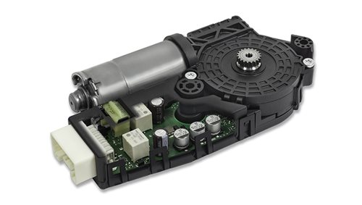

Advantages

* High performance anti-pinch protection
* Short development phases and fast time to market cycles thanks to modular design
* Worldwide support for vehicle parameter adjustments
* Extensive experience as world's top manufacturer of sun roof control units with anti-pinch protection

<https://www.continental-automotive.com/en-gl/Passenger-Cars/Vehicle-Networking/Control-Units/Power-Closures/Sun-Roof-Control-Units>

<https://www.persistencemarketresearch.com/market-research/automotive-roof-control-module-market.asp>

Integrated functions in the vehicle roof

KOSTAL roof modules combine a wide variety of individual components in a single module. The company’s expertise in switch panels, mechanical, electronic and software fields, lighting technology and simulation techniques make KOSTAL the ideal partner in the development of optimum-interface mechatronic modules.

Roof modules

KOSTAL roof modules serve as a gateway for communication between the driver and vehicle sub-systems. Sensor signals, from the EC mirror or rain/light sensor for example, are processed in the roof module. Functions handled by KOSTAL modules include:

* dazzle-free reading lamps and interior lights, using LED or filament lamp technology
* control of the entire lighting scene in the vehicle interior, including reading lamps, interior lights and ambient lighting for other vehicle components
* tilting / sliding sunshine roof with pinch protection
* functional integration of passenger compartment monitoring and vehicle tilt sensors
* evaluation of windscreen sensor signals

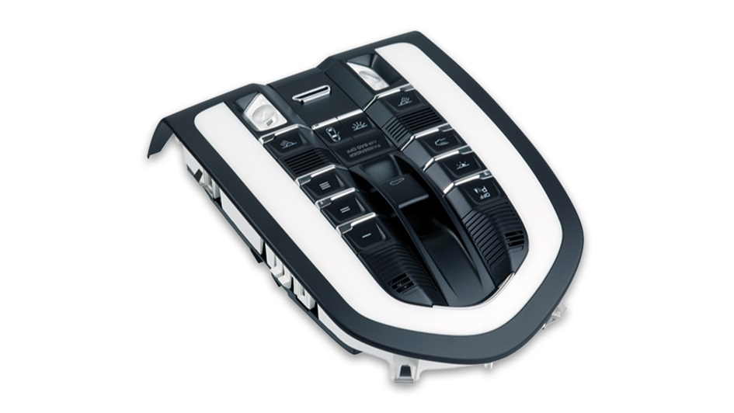

<https://itstillruns.com/power-sunroof-work-4596897.html>

<https://clr.es/blog/en/automobile-sunroof-actuation-system/>

<https://gomechanic.in/blog/6-common-sunroof-problems/>

<https://www.infineon.com/cms/en/applications/automotive/body-electronics-and-lighting/roof-control-module-with-interior-and-ambient-light-control/>

